Design thinking for software engineering
Situation 1: Elderly people feel socially disconnected
1. Observation
- Elderly people miss simple human interactions like talking to family or neighbours. Long periods of silence make them feel forgotten and emotionally isolated.
- Many elderly users feel nervous when using phones or apps because they fear pressing the wrong button. This anxiety makes them avoid communication tools even when they want to connect.
- When calls drop, messages are not sent, or devices do not work as expected, they feel frustrated and disappointed, which lowers their confidence to try again.
- Slow replies from children or relatives make them feel unimportant. Even unintentional delays create emotional pain and discourage future communication.
- Relying on others to set up calls or devices makes them feel like a burden. This dependence reduces their sense of independence and dignity.
- After repeated negative experiences, elderly people stop initiating conversations to avoid feeling hurt. This emotional withdrawal increases their sense of social disconnection.
2. Stakeholder Identification
- Elderly People
Elderly individuals are the main stakeholders who experience social disconnection in daily life. They often feel lonely due to limited interaction, health issues, and difficulty using modern communication tools.
- Family Members
Family members such as children or relatives play an important part in maintaining emotional connections. Due to work and time constraints, they may not always communicate regularly, which affects the elderly’s sense of belonging.
- Caregivers
Caregivers support elderly people in their daily routine and help them communicate with others. They often act as a bridge between elderly individuals and technology or social activities.
- Community and Social Organizations
Community centres, NGOs, and senior groups help create opportunities for social interaction. Their involvement is important in reducing loneliness through group activities and engagement programs.
3. Interviews / Surveys
- How often do you interact with family members or relatives?
- Do you live alone or with family?
- How frequently do you communicate with friends or neighbours?
- Do you feel lonely or isolated in your daily life?
- What are the main reasons you feel socially disconnected?
- Do you participate in social activities or community events?
- Does lack of social interaction affect your mental or emotional health?
- What problems does social disconnection cause you?
- Do you feel that younger family members spend less time with you?
- Are you comfortable using technology (mobile, WhatsApp, video calls) to stay connected?
- What type of support would help you feel more socially connected?
- What suggestions do you have to reduce social isolation among elderly people?
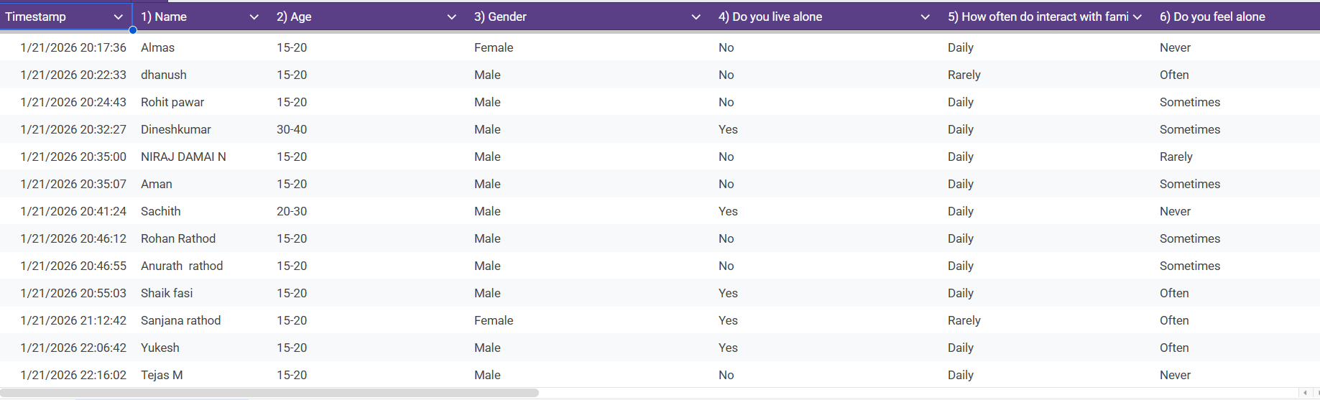
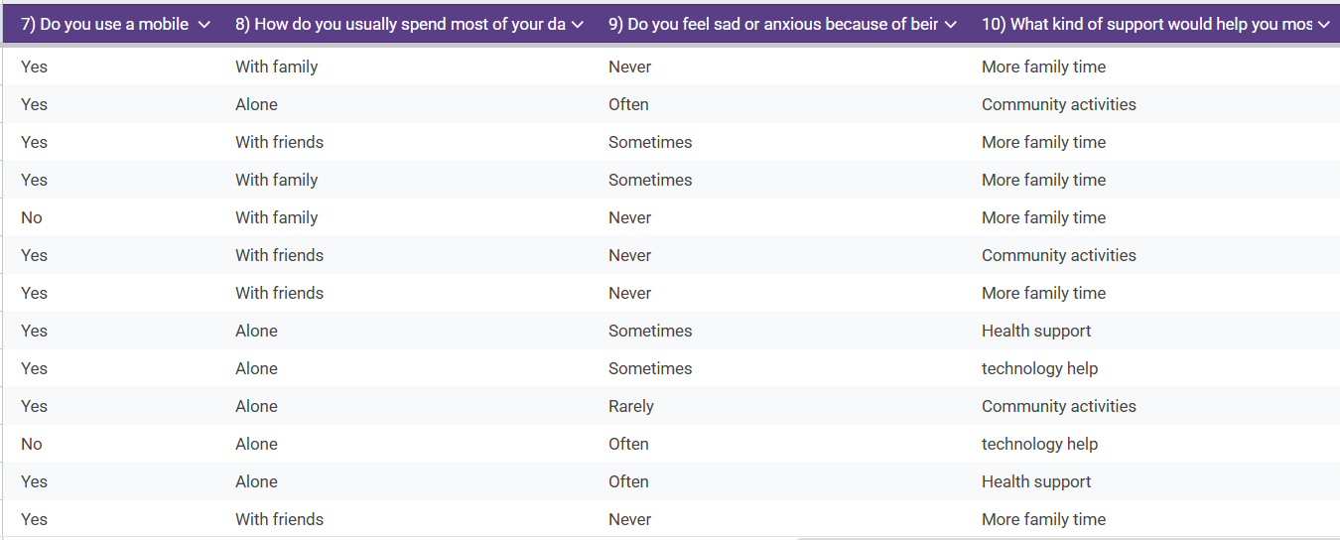
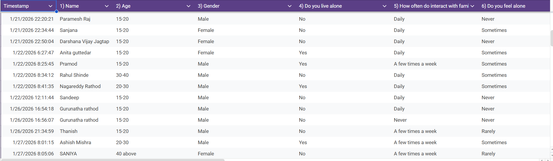
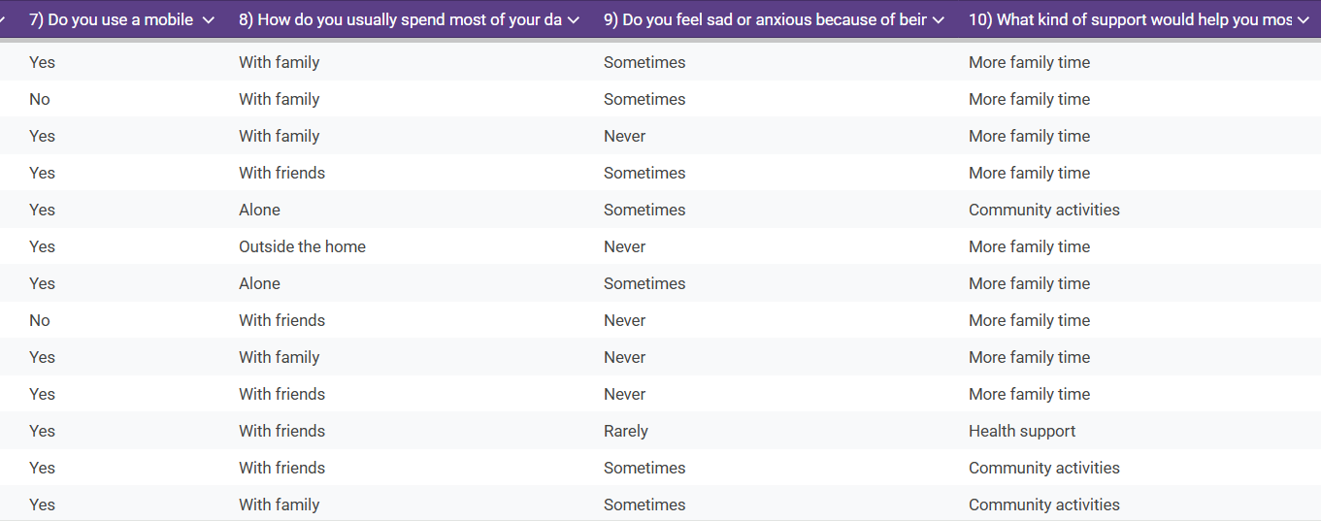
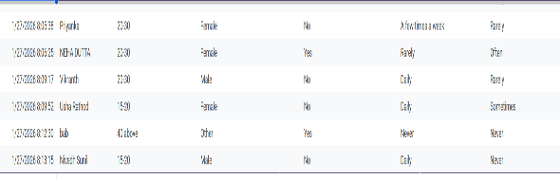
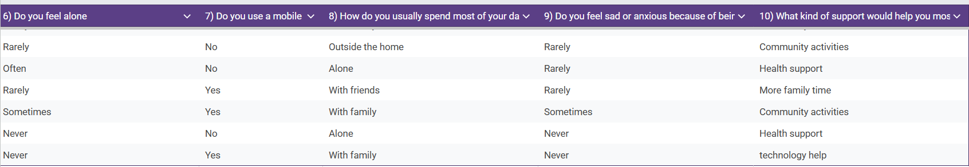
Key Insight
- Living with family does not always prevent loneliness
Many users reported living with family and interacting daily yet still feeling lonely sometimes. This shows that physical presence does not always mean emotional connection.

- Loneliness exists even among younger age groups
Although most respondents are aged 15–20, several reported feeling lonely, anxious, or sad. This indicates that social disconnection is not limited to elderly people and can appear early.

- People who live alone feel loneliness more frequently
Users who reported living alone showed higher responses of “often” or “sometimes” feeling sad or anxious. Isolation increases emotional vulnerability.

- Mobile usage is high, but emotional support is still lacking
Most users use mobile phones regularly, yet loneliness persists. This suggests that access to technology alone does not guarantee meaningful social connection.

- Spending time alone is linked to higher emotional discomfort
Users who spend most of their day alone reported higher levels of sadness or anxiety compared to those spending time with family or friends.

- More family time is the most requested support
Across responses, the most common support needed was “more family time,” showing that users value emotional bonding more than technical solutions.

- Community activities are seen as an important alternative
Several users requested community activities, indicating a desire for shared social spaces and group interaction beyond family.

- Technology help is needed but not the top priority
Some users asked for technology support, but emotional and social needs (family time, community, health support) were more frequently mentioned.

4. Pain-Point Analysis
- Difficulty using communication technology
Elderly users struggle with complex mobile interfaces, small text, and multiple steps, which prevents them from easily calling or messaging loved ones.
- Lack of regular and meaningful interaction
Infrequent contact with family and friends leads to long periods of silence, making elderly individuals feel isolated and socially neglected.
- Emotional distress caused by delayed or no responses
When calls or messages are unanswered, elderly people feel ignored and unimportant, which discourages them from initiating future communication.
- Dependence on others to stay socially connected
Relying on family members or caregivers to operate devices reduces independence and often limits communication when help is unavailable.
- Limited access to community engagement opportunities
Health issues, mobility limitations, and lack of nearby social spaces reduce participation in social activities, increasing isolation.

Most Critical Pain Point
The most critical pain point is the lack of simple and reliable ways to maintain regular social connection. Continuous difficulty in communication combined with emotional neglect leads elderly individuals to withdraw socially, which strongly impacts their mental well-being and quality of life.
5. Root Cause Identification
Critical Pain Point
Lack of simple and reliable ways to maintain regular social connection.
Continuous difficulty in communication, combined with emotional neglect, causes elderly people to withdraw socially, affecting their mental health and overall quality of life.
Why Analysis
- Why are elderly people withdrawing socially?
Because they face repeated difficulty when trying to communicate with family or friends.
- Why do they face difficulty in communication?
Because smartphones, apps, and messaging platforms are confusing and not designed for elderly users.
- Why are these tools confusing for them?
Because small text, multiple steps, complex menus, and notifications make it hard to operate.
- Why is there no guidance or support to use these tools?
Because family members are busy, caregivers are limited, and the systems don’t provide age-friendly tutorials or error help.
- Why does this situation lead to emotional neglect?
Because delayed responses, failed communication attempts, and the lack of confidence to try again make elderly users feel ignored and unimportant.
Root Causes – Clearly Separated from Symptoms
Symptoms:
- Rarely initiating calls or messages.
- Long gaps between social interactions.
- Expressing loneliness or sadness.
- Emotional withdrawal and reduced participation in activities.
Root Causes:
- Communication tools are not designed for elderly cognitive and physical needs.
- Lack of simple, intuitive, and error-tolerant interfaces.
- Absence of guided tutorials, reminders, or support systems.
- Limited availability of family or caregivers to assist regularly.
- Emotional needs (feeling valued and included) are not addressed by current communication systems.
6. Wicked Problem Understanding
1. Difficult to define clearly
- Loneliness and social disconnection are subjective; each elderly person experiences it differently.
- Multiple factors contribute, including technology difficulties, mobility limitations, health issues, and emotional neglect.
- The problem involves personal, social, and technological dimensions, making it hard to capture in a single definition.
- Its intensity and impact vary over time, adding to the challenge of defining it clearly.
2. Multiple stakeholders with conflicting needs
- Elderly people: Want simple, reliable ways to communicate and feel emotionally supported.
- Family members: Want easy ways to stay connected but have limited time and sometimes lack technical skills.
- Caregivers and social organizations: Focus on facilitating social activities or monitoring health, which may not align directly with elderly emotional needs.
- Healthcare providers: Aim to track mental well-being and reduce loneliness but may prioritize health interventions over social engagement.
- Conflicting priorities among stakeholders make addressing all needs simultaneously challenging.
3. Cannot be solved by a single solution
- Social disconnection is caused by emotional, functional, and systemic factors simultaneously.
- Solutions require a combination of interventions: easy-to-use technology, family engagement, caregiver support, and community programs.
- No single tool, app, or activity can fully resolve loneliness or ensure regular social connection for every elderly person.
4. Problem Classification
- Wicked Problem: Because it is complex, multi-dimensional, involves multiple stakeholders with conflicting needs, and cannot be solved by a single solution.

- Reflection
1. Incorrect Assumptions
- I assumed elderly people would easily adapt to smartphones and apps, but observations showed they struggle with complex interfaces.
- I thought family members would always respond promptly to messages or calls, but delays often occur due to busy schedules.
- I assumed community programs alone could reduce loneliness, but many elderly individuals face mobility or health constraints that prevent participation.
2. Change in Understanding Through User Perspectives
- I realized that loneliness is not only about being physically alone but also about feeling emotionally neglected.
- Elderly users want independence and confidence when using communication tools, not just external help.
- Small obstacles like unclear instructions or delayed responses can greatly affect their willingness to engage socially.
3. Why Jumping to Solutions is Risky
- Solving the problem without fully understanding user behavior may create tools or services that are unusable or ignored.
- Quick solutions might focus only on technology while ignoring emotional or social needs, leaving the core problem unresolved.
- Each elderly person’s situation is unique, so a one-size-fits-all approach can fail.

4. Skills Developed Through This Lab
- Observing and analyzing real user behaviour carefully.
- Identifying pain points and distinguishing between symptoms and root causes.
- Understanding diverse stakeholder perspectives.
- Applying structured tools like 5-Why Analysis for problem-solving.
- Empathy development: seeing the problem from the user’s human perspective.
- Communicating findings clearly in written and point-wise form.

